Write Generously: Audience-Centered Practice for Research Talks and Papers
Workshop from VIS SEA 2026
Collaboration of VIS researchers from Davidson, Emory, Georgia Tech, Virginia Tech, and Clemson

Abstract
Researchers spend years learning to produce results and comparatively little time learning to communicate them. This paper distills a lab discussion on research communication into a single organizing principle, generosity toward the audience, and a set of concrete practices that follow from it. For conference talks, these practices cover delivery mechanics, orientation of a mixed audience, and structural signposting. For papers, they cover titles and abstracts, the boundary between the introduction and related work, positioning within a research lineage, summary figures for statistical results, and writing for the reviewer's experience. The paper closes with four synthesized tests a draft or talk should pass before submission: manage the reader's cognitive load, deliver one memorable takeaway, link every claim to its evidence, and resolve reviewer friction before it occurs.

Introduction
A research contribution only matters if someone else can absorb it. Conference talks and papers are the two channels through which that transfer happens, and both reward the same underlying discipline: treating the audience's attention as something the author must earn and repay. This paper names that discipline generosity. A generous author gives the audience context before detail, states what they will receive before delivering it, and spends effort so the reader does not have to.
Generosity is a practical stance. Listeners give up their time to attend a talk; readers give up theirs to work through a paper. The author's obligation is reciprocal: make the exchange worth it. The sections below translate that obligation into specific practices, first for talks, then for papers, and finally for the review process that sits between a paper and its audience.

Delivering the Talk

Delivery mechanics
Filler words, chiefly "like" and "um," distract the audience and dilute authority. Two techniques reduce them. First, record a practice run and count the fillers; awareness alone removes many of them. Second, when a filler starts to surface, stop and restart the sentence. Silence works in the speaker's favor. A pause signals that the audience should wait for the next thought, and it lets the previous thought land. Speakers who fear silence tend to fill it; speakers who use it hold attention.
Pace matters for the same reason. A speaker rushing through a podium talk outruns the audience's ability to process; slowing down costs a small amount of content and buys comprehension. Scripting a talk is acceptable, with a caveat: a script read cold sounds flat, so a scripted talk requires enough rehearsal to deliver it with energy.
Speakers should also expect blank faces and resist over-interpreting them. Large or time-bounded audiences hold questions to the end and give the presenter little feedback in the moment; an unresponsive room is normal at scale. Losing confidence mid-presentation because the room looks flat is a common failure mode, and recognizing the pattern defuses it.

Orienting a mixed audience
Even within a single research community, attendees work on different problems and cannot be assumed to share background. A brief background segment at the start of a talk, before the technical contribution, tells the audience what came before and why the problem exists. Presenters pressed for time cut this segment first, and it is the wrong cut; without it, the detailed material that follows has nothing to attach to.
No single talk resolves audience heterogeneity. A room holds novices and experts, and no single level of exposition serves both. The pressure eases as the audience grows: with hundreds of listeners, the speaker aims for the center of the distribution and accepts the tails. Mid-sized audiences are hardest, because serving everyone looks feasible and is not.

Structure and signposting
A reliable macro-structure for a talk is to tell the audience what they will hear, tell them, and then tell them what they heard. The opening sets anticipation, the body delivers, and the closing fixes the takeaway. Explicit transitions serve the same function at finer grain; an audience that can anticipate the next section stays oriented, which matters more as talks get longer. A twelve-minute talk survives a loose structure; a forty-five-minute talk does not.
Light interaction can re-engage a room. A quick multiple-choice question or show of hands prompts listeners to test their own understanding. The technique carries a risk: a question the audience gets wrong can create an adversarial dynamic, so check-ins should invite thought without setting up the speaker as gatekeeper.
A useful test for the whole talk: could a listener describe it to someone else at dinner that evening? A talk that survives retelling had a clear, simple core. A memorable formulation in visualization research, that a viewer will act on a chart when it is one color but not another, spreads because a listener can carry it out of the room and repeat it. Complicated talks without a compressible core leave the room with the speaker.

Generosity as the Organizing Principle
The practices above share a root. Each asks the presenter to do work so the audience does not have to: rehearse so listeners are not distracted, provide background so they are not lost, signpost so they are not disoriented, compress so they leave with something. The same root produces good papers.
Authors can train this empathy. Authors have sat through boring talks and abandoned confusing papers; cataloging what made those experiences bad, and what made the memorable ones good, converts a lifetime of audience experience into design guidance for one's own communication. The author is never guessing what a confused reader feels, because the author has been that reader.

Writing the Paper

Titles and abstracts
The title should be the simplest statement of the work; the abstract adds a layer of information; the paper carries the full technical depth. This gradient is the title's job, and dense technical titles invert it by demanding expertise before granting entry. "Attention Is All You Need" [1] demonstrates the pattern: a plain-language title over deep technical content, and among the most cited papers in machine learning. A simple title with a complex story underneath outperforms a complex title, because the title's audience is the reader who has not yet decided to read.
Abstracts should state results. Announcing the finding up front gives the reader concrete questions, about validity, sample size, and method, that motivate reading the full paper. The closing sentences of the abstract should tell readers exactly what they will get. A practical drafting technique: write the abstract twice, once before the paper as a placeholder and once after, when the author knows what the paper honestly claims.
The same logic applies inside the paper. Research questions laid out explicitly, early, and in bold give the reader a contract: read on and these will be answered. Exploratory framings ("understanding X," "investigating Y") withhold that contract and leave the reader unsure what knowledge the paper offers in exchange for their time. An applied-lab habit worth keeping: place a concrete usage scenario in the second paragraph of the introduction, showing how a person would benefit from the system, so the value of the work is evident before any technical material appears.

Introductions versus related work
A common structural failure is an introduction that reads as a compressed related-work section: a sequence of prior-work summaries with the contribution appended. The fix is to treat the introduction as an extended abstract instead. Open with the problem, give an example of why it matters, gesture briefly at what exists, then preview the research questions and results. Depth of engagement with prior work belongs in the related-work section, where a smaller number of papers discussed substantively serves the reader better than a general claim trailing a bracket of ten citations.

Positioning within a lineage
Introductions that motivate the work by disparaging prior approaches ("X fails at this, Y fails at that") create friction with reviewers, who often authored X and Y. The stronger framing is extension: name the vein of research the work continues, show where it sits in that family tree, and present the contribution as momentum for the discipline. Reviewers want existing work extended, and locating the paper in a lineage partially validates it before the contribution is even evaluated.

Clear takeaways
Papers earn acceptance with claims a reviewer can believe and repeat. The finding that people estimate length more accurately than area, and area more accurately than volume [2], persists because it is clear, usable, and backed by controlled experiments. Early perception studies show the same virtue; a study of how readers estimate proportions in pie charts, comparing angle, arc length, and area as candidate cues, remains explainable at a whiteboard a century later because its authors wrote to be digested. [TODO: verify and cite the early pie chart perception study; the discussion dated it to 1922, and candidates include Eells and Croxton-era work] The pattern generalizes beyond visualization: a 1950s retail-geography study that mapped a grocery chain's customer trade areas from check-cashing records and newspaper circulation remains a model of a paper readable start to finish. [TODO: verify and cite the 1950s Stop & Shop trade-area study] Older papers often read better because scarce publication opportunities and manual typesetting forced authors to invest in each manuscript; the lesson transfers even though the constraints do not.
A tension arises here. Authors feel pressure to inflate the apparent importance of a manuscript because plainly stated work risks a "not novel" verdict in review. The tension is real, and the resolution offered here is partial: importance signaled through clarity, positioning, and a strong takeaway survives review better than importance signaled through complexity, which alienates the very readers who decide the paper's fate.

Figures
Reviewers repeatedly praise strong figures, and figure design is a learnable, reusable skill. A specific reusable pattern for experimental papers: a single summary figure with one column per hypothesis, each column carrying a one-sentence statement of what happened and its p-value, with strongly significant results set in bold and non-significant results grayed out. This directly answers a recurring reviewer complaint, that long prose runs of p-values are unreadable, by letting the reader absorb the outcome of every hypothesis at a glance. Once built, the template amortizes across papers and proposals.
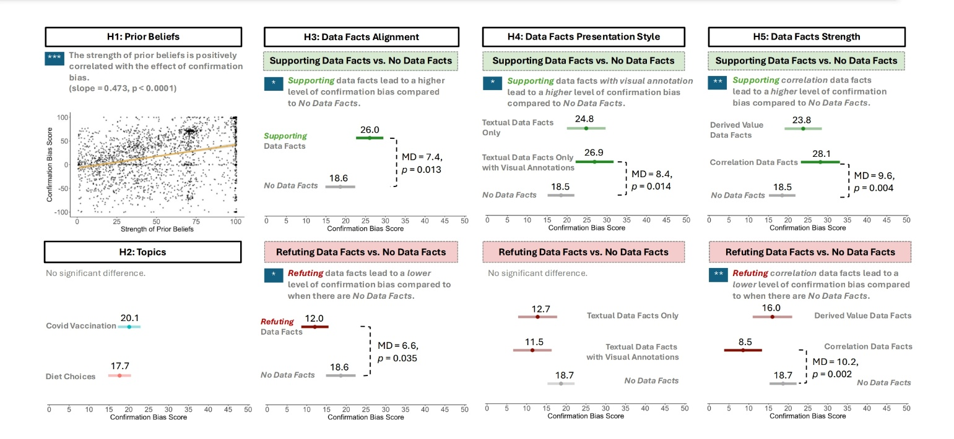
Figure 1 - The figure above provides a pattern for reuse to emphasize data and results for each hypthesis
Cartography offers a second source of transferable figure craft. The field trains designers explicitly in line weight, white space, balance, typographic hierarchy, and color, and its tools have crossed over; ColorBrewer [3], built by a cartographer, provides perceptually balanced color palettes now standard in Python and R plotting workflows. Authors who do not consider themselves figure designers can borrow a collaborator's template and iterate; the skill compounds.

The Reviewer Experience
A paper's first audience is its reviewers, and reviewing has a user experience. Reviewers are human: some papers frustrate them into breaks, and others read as clearly above the bar. Authors typically optimize for acceptance directly; optimizing instead for the reviewer's reading experience, responsibly, by reducing confusion, friction, and unearned effort, targets the same outcome through a mechanism the author controls. Whether reviewer enjoyment correlates with acceptance is an open empirical question, but the author's own experience as a frustrated reviewer supplies the design guidance.
Review remains noisy regardless. Rejections frequently reflect scope judgments ("not a fit for this venue"), reviewer bias, or the forced ranking of several good papers rather than a defect the author can fix, and reviewers score independently of the meta-reviewer who makes the final call. Repeated rejection of sound work happens; the practices in this paper improve the odds without promising the outcome. The same audience-centered stance extends to funding proposals, where a reviewer reading a well-crafted proposal wants to fund it immediately, and where the author's genuine enthusiasm for the idea shows through in the writing.

Four Tests Before Submission
Four synthesized tests compress this paper's guidance into a pre-submission checklist.
- Cognitive load. Each paragraph and each figure should carry one clear idea. If a unit of the paper asks the reader to hold several, split it.
- One takeaway. The work should reduce to one sentence a reader can repeat six months later. If no such sentence exists, the contribution is not yet in focus.
- Claims linked to evidence. Every claim should point explicitly at its support. Trust is built into the manuscript when the reader never has to hunt for the basis of an assertion.
- Reviewer friction. Anticipate the moments where a reviewer will stop and ask "wait, why?", and resolve them in the text before they occur.

Conclusion
Generosity unifies the craft of research communication. The generous author rehearses, orients, signposts, and compresses in talks; titles plainly, states results early, extends rather than disparages, and summarizes visually in papers; and writes for the reviewer's experience because the reviewer is the first reader. None of these practices requires talent. They require adopting the audience's seat, which every author has occupied, and doing the work there first.

References
[1] A. Vaswani et al., "Attention Is All You Need," Advances in Neural Information Processing Systems (NeurIPS), 2017.
[2] W. S. Cleveland and R. McGill, "Graphical Perception: Theory, Experimentation, and Application to the Development of Graphical Methods," Journal of the American Statistical Association, 79(387), 1984.
[3] M. Harrower and C. A. Brewer, "ColorBrewer.org: An Online Tool for Selecting Colour Schemes for Maps," The Cartographic Journal, 40(1), 2003.

